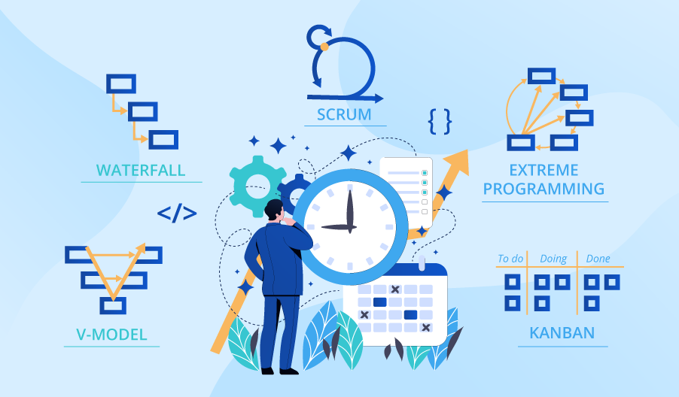

**SE423**

**Software Project Management**

**Assignment**

**Assignment 4.**

Answer the following questions:

1. What is the definition of software quality?
2. What is the definition of software quality assurance?
3. Create a list of common activities associated with SQA. Which do you think are most effective?
4. Examine the techniques available for technical reviews. What are the advantages/disadvantages of using one technique over another?
5. Your project plans calls for all software artifacts to be formally inspected. You are falling behind in the schedule and need to make a decision on the inspection process. What are your options and what would you suggest?

Submit your answers to LMS as PDF file.